**THE UNHOLY WAR IN THE HOLY LAND**

**(PALESTINE)**

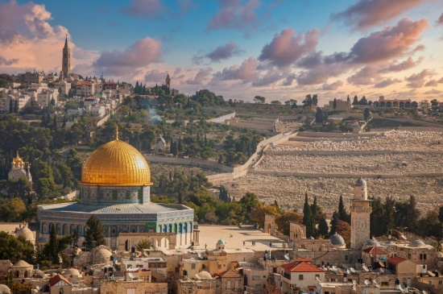

Author:

**Ayesha Tariq**1

**Muhammad Bux Alvi**1

Institute: **The Islamia University of Bahawalpur**1

**Abstract:**

In current situation, as in the past, many international wars could be explained in terms of geopolitical factors. The Israeli-Palestinian war has been most significant since the emergence of the modern state of Israel in 1948, resulting from the November 29, 1947 United Nations Resolution 181 adopted for two states creation in Palestine: one Arab, one Jewish. On May 14, 1948, the State of Israel was created, sparking the first Arab-Israeli War. The Palestinian state have suffered unnecessary paralysis due to social psychological perceptions and political problem between the two sides. All of this is because of the “AL AQSA” for which the followers of all the religions are struggling to gain control over it for many years because of its historical background. Therefore, Hamas and Israeli forces are struggling and fighting to gain control over the Palestine. For many years Israel is attacking on Palestine time to time to take control over it. On November 29, 2012 the UN General Assembly resolution upgrading the Palestinian Authority from UN “observer” to “non-state member observer” status was a significant political achievement for the Palestinians, but tie up with political landmines. But a Palestinian state can be accomplished if certain barriers are removed, with honesty of purpose on both sides and the third party go-between.

**Historical Background of Palestine:**

Scholars believe the name **“Palestine”** originally comes from the word “Philistia,” which refers to the Philistines who occupied part of the region in the 12th century B.C. Throughout history, Palestine has been ruled by numerous groups, including the Assyrians, Babylonians, Persians, [Greeks](http://www.history.com/topics/ancient-history/ancient-greece), [Romans](http://www.history.com/topics/ancient-history/ancient-rome), Arabs, Fatimid’s, Seljuk Turks, [Crusaders](http://www.history.com/topics/crusades), [Egyptians](http://www.history.com/topics/ancient-history/ancient-egypt) and Mamelukes. From about 1517 to 1917, the [Ottoman Empire](https://www.history.com/topics/ottoman-empire) ruled much of the region.

When [World War I](https://www.history.com/topics/world-war-i) ended in 1918, the British took control of Palestine. The [League of Nations](http://www.history.com/this-day-in-history/league-of-nations-instituted) issued a British mandate for Palestine a document that gave Britain administrative control over the region, and included provisions for establishing a Jewish national homeland in Palestine which went into effect in 1923.

**Introduction:**

In 1947, after more than two decades of British rule, the [United Nations](http://www.history.com/this-day-in-history/the-united-nations-is-born) proposed a plan to partition Palestine into two sections: an independent Jewish state and an independent Arab state. The city of [Jerusalem](https://tempest.saymedia.com/topics/history-of-jerusalem), which was claimed as a capital by both Jews and Palestinian Arabs, was to be an international territory with a special status. Jewish leaders accepted the plan, but many Palestinian Arabs some of whom had been actively fighting British and Jewish interests in the region since the 1920s are opposed to it. Arab groups argued that they represented the majority of the population in certain regions and should be granted more territory. They began to form volunteer armies throughout Palestine.

The 1948 Arab-Israeli War that ensued involved Israel and five Arab nations Jordan, Iraq, Syria, Egypt and Lebanon. By the war's end in July 1949, Israel controlled more than two-thirds of the former British Mandate, while Jordan took control of the West Bank and Strip. The 1948 war opened a new chapter in the struggle between Jews and Palestinian Arabs, which now became a regional contest involving nation-states and a tangle of diplomatic, political and economic interests.

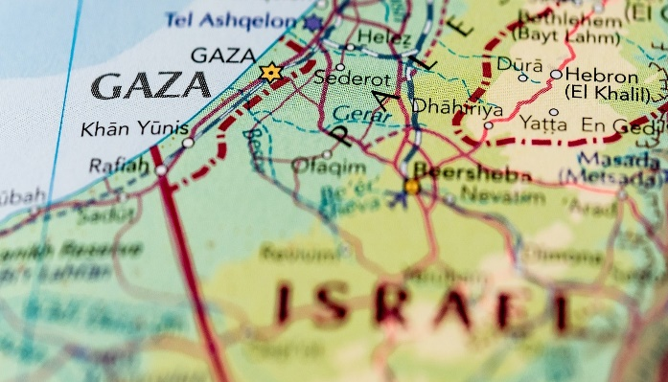

**Reason of Israel’s creation:**

In 1948, unable to solve the problem, Britain withdrew and Jewish leaders declared the creation of the State of Israel. It was intended to be a safe haven for Jews fleeing persecution, as well as a national homeland for Jews.

Fighting between Jewish and Arab militias had been intensifying for months, and the day after Israel declared statehood, five Arab countries attacked.

Hundreds of thousands of Palestinians fled or were forced out of their homes in what they call Al Nakba, or [the "Catastrophe"](http://www.bbc.co.uk/news/world-middle-east-44114385).

By the time the fighting ended in a ceasefire the following year, Israel controlled most of the territory.

Jordan occupied land which became known as the West Bank, and Egypt occupied Gaza.

Jerusalem was divided between Israeli forces in the West, and Jordanian forces in the East.

Because there was never a peace agreement there were more wars and fighting in the following decades.

## **Israel’s War of Independence and the Palestinian Nakba:**

On November 29, 1947, the [United Nations](https://www.britannica.com/topic/United-Nations) (UN) voted to partition the British [mandate](https://www.merriam-webster.com/dictionary/mandate) of Palestine into a Jewish state and an Arab state ([United Nations Resolution 181](https://www.britannica.com/topic/United-Nations-Resolution-181)). Clashes broke out almost immediately between Jews and Arabs in Palestine, beginning with the Arab ambush of a bus carrying Jewish passengers from [Netanya](https://www.britannica.com/place/Netanya) to [Jerusalem](https://www.britannica.com/place/Jerusalem) on November 30. As British troops prepared to withdraw from Palestine, conflict continued to escalate, with both Jewish and Arab forces committing hostile acts. Among the most infamous events was the attack on the Arab village of [Deir Yassin](https://www.britannica.com/place/Deir-Yassin) on April 9, 1948. The news of a massacre there by [Irgun Zvai Leumi](https://www.britannica.com/topic/Irgun-Zvai-Leumi) and the [Stern Gang](https://www.britannica.com/topic/Stern-Gang) forces spread widely and inspired both panic and retaliation. Days later, Arab forces attacked a Jewish convoy headed for Hadassah Hospital, killing 78.

**Map:**

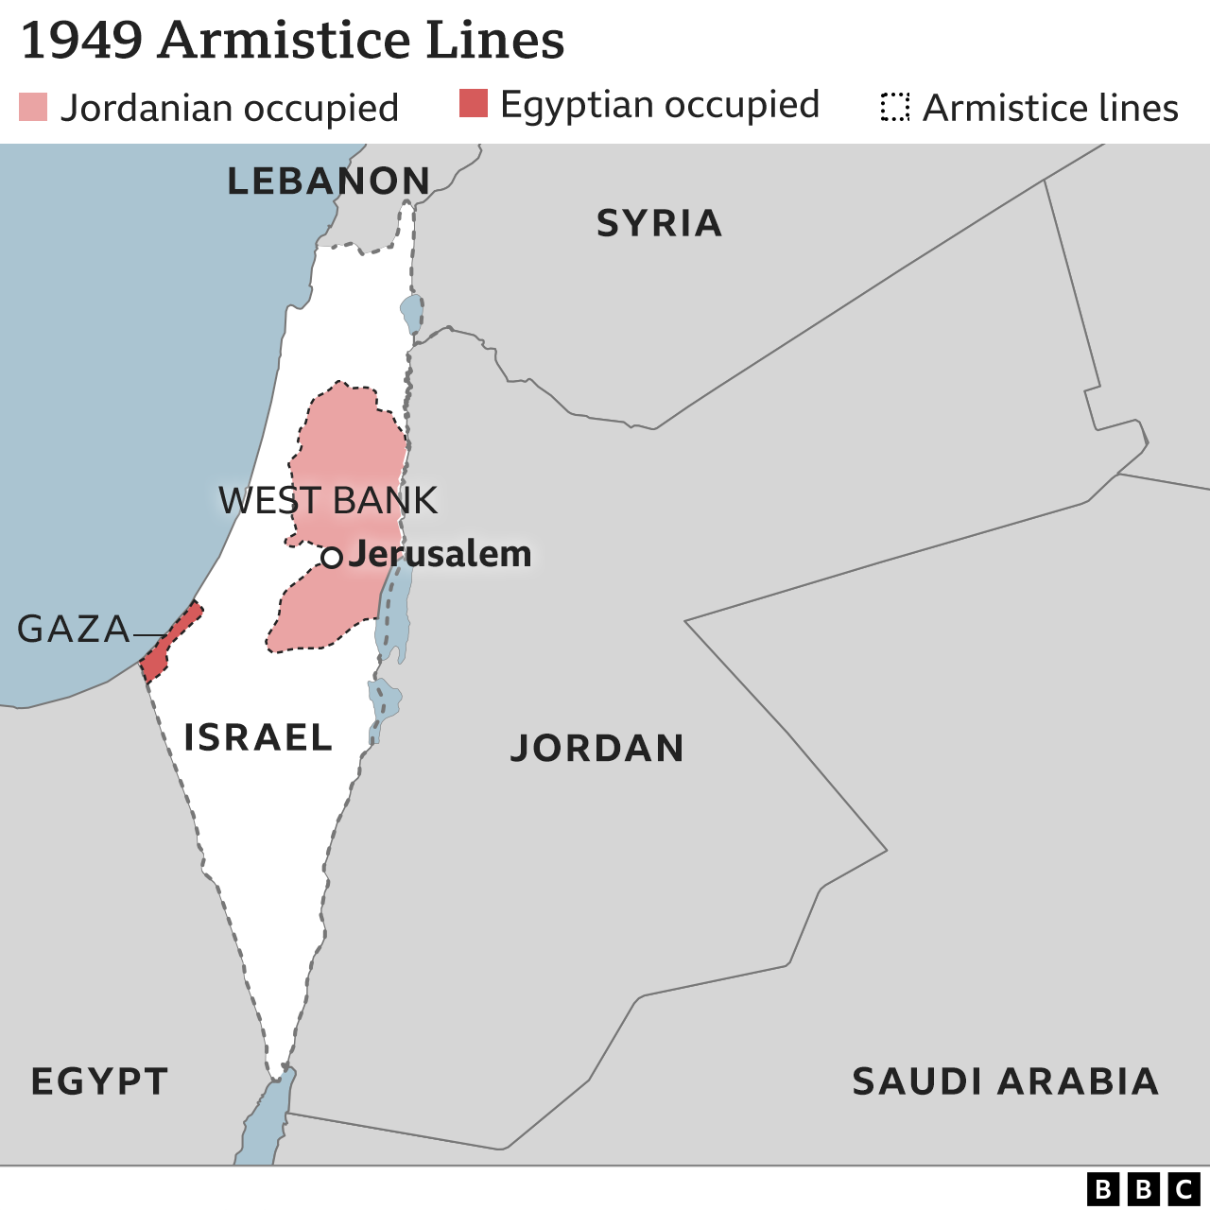

**Creation of PLO:**

In 1964, the [Palestine Liberation Organization (PLO)](http://www.history.com/this-day-in-history/plo-is-founded) was formed for the purpose of establishing a Palestinian Arab state on the land previously administered under the British Mandate, and which the PLO considered to be occupied by the State of Israel. Although the PLO was originally dedicated to the destruction of the State of Israel as a means of attaining its goal of Palestinian statehood, in the 1993 Oslo Accords, the PLO accepted Israel's right to exist in exchange for formal recognition of the PLO by Israel a high water mark in Israeli-Palestinian relations. In 1969, the well-known Palestinian leader [Yasser Arafat](http://www.history.com/this-day-in-history/arafat-elected-leader-of-palestine) became the Chairman of the PLO and held that title until he died in 2004.

**Hamas:**

In 2006, Hamas, a Sunni Islamist militant group, won the Palestinian legislative elections. That same year, fighting between Hamas and Fatah, the political group that controlled the PLO, ensued. In 2007, Hamas defeated Fatah in a battle for Gaza. Many countries consider Hamas to be a terrorist organization. The group has carried out suicide bombings and repeatedly called for the destruction of Israel. Hamas and Israel fought each other in several bloody wars, including Operation Cast Lead in December 2008, Operation Pillar of Defense in November 2012 and Operation Protective Edge in July 2014.In April 2014, Hamas and Fatah agreed to a deal that would form a unified national Palestinian government.

**Opening of war:**

Palestinians refused to recognize the resolution, and violent conflict between both groups continued. On May 15, 1948, Israel declared independence, thus beginning the Israeli-Arab War, with five Arab states fighting against the creation of the state. The United Nations resolution sparked conflict between Jewish and Arab groups within Palestine. Fighting began with attacks by irregular bands of Palestinian Arabs attached to local units of the Arab Liberation Army composed of volunteers from Palestine and neighboring Arab countries. These groups launched their attacks against Jewish cities, settlements, and armed forces. The Jewish forces were composed of the Haganah, the underground militia of the Jewish community in Palestine, and two small irregular groups, the Irgun, and LEHI. The goal of the Arabs was initially to block the Partition Resolution and to prevent the establishment of the Jewish state. The Jews, on the other hand, hoped to gain control over the territory allotted to them under the Partition Plan.

In September 2000, the Second Palestinian Intifada began. One of the triggers for the violence was when Ariel Sharon, a right-wing, Jewish Israeli who would later become Israel’s prime minister, visited the Muslim holy site at the al-Aqsa Mosque in Jerusalem. Many Palestinians felt this was an offensive move, and they protested. Riots, suicide bombings and other attacks subsequently broke out, putting an end to the once-promising peace process. This period of violence between Palestinians and Israelis lasted nearly five years. Yasser Arafat died in November 2004, and by August of 2005, the Israeli army withdrew from Gaza.

**Attempts to make peace:**

In 1979, Egypt and Israel signed a peace treaty, ending 30 years of hostility. In 1993, Israeli Prime Minister Yitzhak Rabin and Arafat shook hands on the Oslo Accords on limited Palestinian autonomy. In 1994, Israel signed a peace treaty with Jordan.The Camp David summit of 2000 saw President Bill Clinton, Israeli Prime Minister Ehud Barak and Arafat fail to reach a final peace deal.

In 2002, an Arab plan offered Israel normal ties with all Arab countries in return for a full withdrawal from the lands it took in the 1967 Middle East war, creation of a Palestinian state and a "just solution" for Palestinian refugees.

Peace efforts have been stalled since 2014, when talks failed between Israelis and Palestinians in Washington. Palestinians later boycotted dealings with the administration of U.S. President Donald Trump since it reversed decades of U.S. policy by refusing to endorse the two-state solution - the peace formula that envisages a Palestinian state established in territory that Israel captured in 1967.

## **Current State of Palestine:**

Palestinians are still fighting for an official state that’s formally recognized by all countries. Although Palestinians occupy key areas of land, including the West Bank and the Gaza Strip, some Israelis, with their government's blessing, continue to settle in areas that are generally agreed to be under Palestinian control. Many international rights groups consider such settlements illegal, the borders aren’t clearly defined, and persistent conflict continues to be the norm. A [substantial proportion](https://www.jewishvirtuallibrary.org/israeli-opinion-on-settlements-and-outposts-2009-present) of Israelis also oppose the settlements and would prefer to find peaceful ways to resolve their land disputes with the Palestinians.

In May 2017, leaders of Hamas presented a document that proposed the formation of a Palestinian state using the 1967 defined borders, with Jerusalem as its capital. However, the group refused to recognize Israel as a state, and the Israeli government promptly rejected the plan.

In May 2018, tensions erupted when the U.S. Embassy relocated from Tel Aviv to Jerusalem. Perceiving this as signal of American support for Jerusalem as Israel’s capital, Palestinians responded with protests at the Gaza-Israel border, which were met with Israeli force resulting in the deaths of dozens of protesters.

In October 2023, Hamas militants launched a coordinated assault on Israel, killing hundreds of Israelis, many of them civilians, leading Israel Prime Minister Benjamin Netanyahu to declare "we are at war." Israel began retaliatory airstrikes in Gaza, leading to hundreds of Palestinian deaths.

**Death Rate due to conflicts (2008 to 2023):**

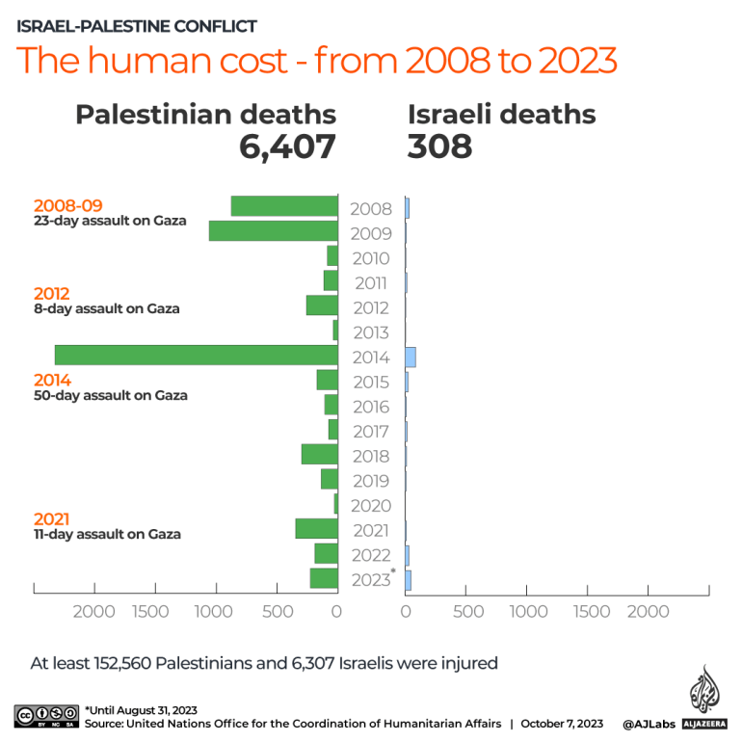

**Recent Conflict:**

Almost one week since Hamas launched a multipronged assault on southern Israel on 7 October, fighting has subsided inside Israel, while Israeli airstrikes have hit Gaza on an “unprecedented scale”.

Tensions have risen along Israel’s northern border amid the escalating conflict, as violence continues at heightened levels in the West Bank.

Violence inside Israel has abated since the Israel Defense Forces (IDF) announced it had regained control of all territories along the border with Gaza on 10 October, mining the area to prevent any renewed incursion, more than 72 hours after the Hamas surprise attack.

Despite the announcement, a small number of Hamas militants have remained inside Israeli territory.

 The official Israeli death toll for the initial day of the Hamas assault has continued to rise, surpassing 1,300. The majority have been civilians, with the IDF putting the number of military fatalities at 264.

Hamas has also continued launching hundreds of rockets into Israel. While the majority of rockets have been intercepted by Israel’s Iron Dome air defense system, there have been a small number of direct hits.

Two foreign workers were killed in Eshkol regional council on 10 October in a rocket attack, while about a dozen people were injured in Ashdod on 11 October.

A further five Israelis were reported injured, two severely, in another rocket attack on 12 October in Sderot. At least one moderate and three light injuries were also reported on 13 October in Rehovot.

As of 13 October, Israel is still preparing for a potential ground invasion of Gaza, with a massive military buildup continuing along the border. But with Hamas holding an estimated 200 Israeli soldiers and civilians captured inside Gaza, the potential Israeli operation faces severe challenges.

The Israeli military suggested on Thursday morning that no political decision regarding the launch of the ground operation had yet been made.

Israel, however, issued a warning to Palestinians in northern Gaza on 13 October to relocate to southern Gaza within the next 24 hours, suggesting that a ground operation may be imminent.

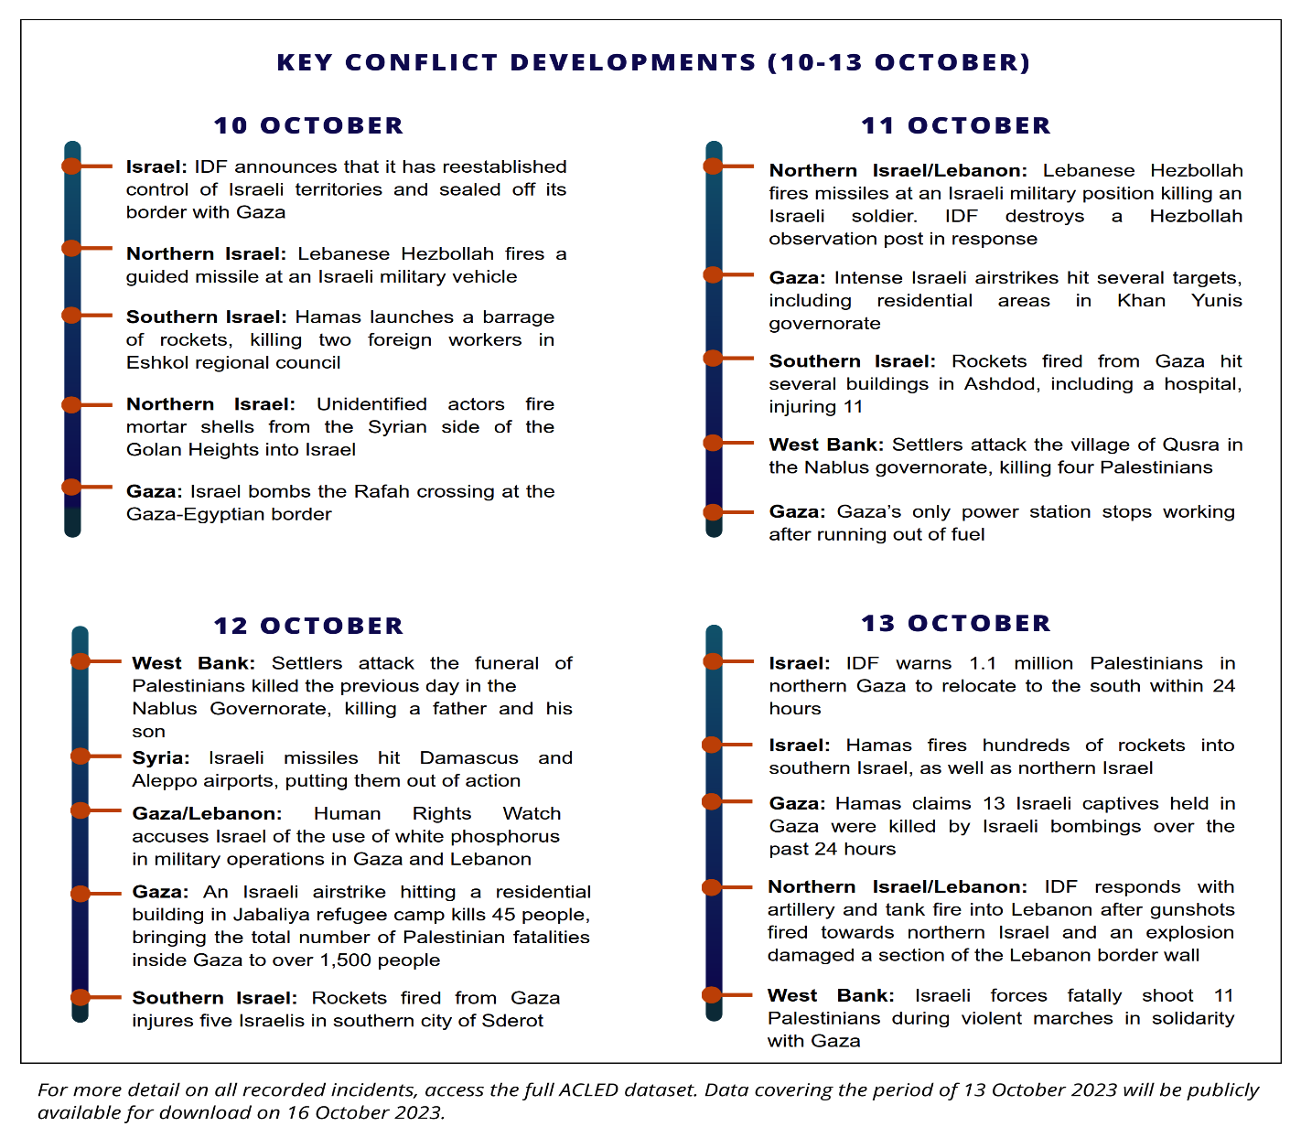

**Recent Developments:**

The [most far-right and religious government](https://www.nytimes.com/2022/12/22/world/middleeast/israel-netanyahu-government.html?action=click&algo=bandit-all-surfaces-time-cutoff-30_impression_cut_3_filter_new_arm_5_1&alpha=0.05&block=more_in_recirc&fellback=false&imp_id=273451210&impression_id=29a2bc24-87b3-11ed-b984-1fa3695edda2&index=4&pgtype=Article&pool=more_in_pools%2Fmiddleeast&region=footer&req_id=515306421&surface=eos-more-in&variant=0_bandit-all-surfaces-time-cutoff-30_impression_cut_3_filter_new_arm_5_1) in Israel’s history was inaugurated in late December 2022. The coalition government is led by Benjamin ‘Bibi’ Netanyahu and his Likud party and comprises two ultra-Orthodox parties and three far-right parties, including the Religious Zionism party, an ultranationalist faction affiliated with the West Bank settler movement. To reach a governing majority, Netanyahu made a variety of [concessions](https://www.barrons.com/news/netanyahu-s-controversial-concessions-to-israel-govt-partners-01672326009) to his far-right partners.

Opponents have criticized the government’s stated [prioritization](https://www.dw.com/en/israel-new-netanyahu-government-vows-to-expand-settlements/a-64228466#:~:text=Benjamin%20Netanyahu's%20incoming%20far%2Dright,Israel's%20ties%20with%20the%20US.) of the expansion and development of Israeli settlements in the occupied West Bank.

2022 [marked](https://news.un.org/en/story/2022/12/1131852#:~:text=More%20than%20150%20Palestinians%20and,the%20Security%20Council%20on%20Monday.) a renewed level of violence between Israelis and Palestinians. The first nine months of 2023 were characterized by a steady trend of clashes in the West Bank, including nearly daily [Israeli incursions](https://www.washingtonpost.com/world/2023/02/28/palestine-israel-far-right-violence-surge/).

Israel [approved](https://www.reuters.com/world/middle-east/israel-approves-thousands-building-permits-west-bank-2023-06-26/) five thousand new settler homes in June 2023 which, along with other settlements in Palestinian territory, [are considered](https://www.ohchr.org/en/press-releases/2021/07/israeli-settlements-amount-war-crime-special-rapporteur-tells-human-rights) by experts and intergovernmental institutions to be illegal under international law.

The Israeli military also escalated its operations, including [raiding](https://edition.cnn.com/2023/04/05/middleeast/israel-al-aqsa-mosque-clash-intl-hnk/index.html?) the al-Aqsa mosque twice in one day, wounding thirty-five in a [Ramallah operation](https://www.reuters.com/world/middle-east/israeli-army-mounts-rare-raid-into-palestinian-city-ramallah-clashes-ensue-2023-06-07/), and [firing missiles](https://www.bbc.com/news/world-middle-east-65949618) from a helicopter at the Jenin refugee camp.

In May, Israel battled Gazan militants for five days, with nearly two thousand combined [missile launches](https://www.timesofisrael.com/breaking-calm-one-rocket-launched-from-gaza-at-ashkelon-no-injuries/?) by Hamas and Israeli forces.

Then, in July, Israel deployed nearly two thousand troops and conducted drone strikes in a [large-scale raid](https://www.nytimes.com/2023/07/05/world/middleeast/israel-withdraws-jenin-west-bank.html?) on the Jenin refugee camp in the West Bank, killing twelve Palestinians and wounding fifty.

Israel, which lost one soldier in the operation, claimed all those killed were militants. While withdrawing, Israeli Prime Minister Benjamin Netanyahu said the incursion was “[not a one-off](https://apnews.com/article/israel-palestinians-jenin-west-bank-militants-gaza-strip-2aa6352e798a671d26331ca57ce3a565?)” incident; Israel intends to prevent the camp from serving as a [safe haven](https://www.nytimes.com/2023/07/02/world/middleeast/israel-west-bank-jenin.html) for Jenin Brigades and other militant groups.

Hamas responded to the raid by carrying out an [attack](https://www.cnn.com/2023/07/04/middleeast/tel-aviv-car-ramming-attack-intl/index.html) in Tel Aviv and [launching missiles](https://www.theguardian.com/world/2023/jul/05/israel-jenin-forces-withdraw-gaza) at Israel.

The October 2023 conflict between Israel and Hamas marks the most significant escalation of the ongoing Israeli-Palestinian conflict in several decades

**Recant Air strikes in Gaza:**

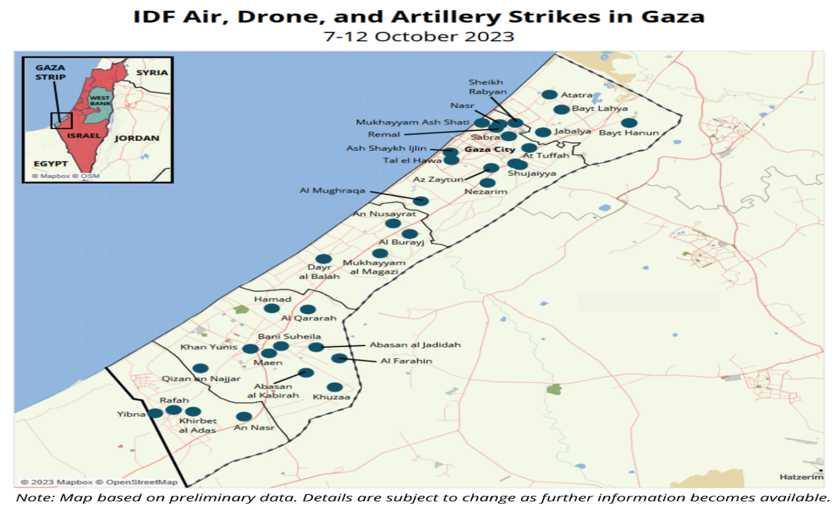

**Recant Death Rate in Palestine:**

Since 7 October 2023, more than 1,900 Palestinians have been killed, including at least 600 children, more than 7,600 injured, and over 423,000 people have been displaced as a result of the Israeli strikes.

**Main Palestinian-Israeli issue:**

A two-state solution, Israeli settlements, the status of Jerusalem, and refugees are at the core of the dispute.

Two-state solution - an agreement that would create a state for the Palestinians in the West Bank and Gaza Strip alongside Israel. Hamas rejects the two-state solution and is sworn to Israel's destruction. Israel has said a Palestinian state must be demilitarised so as not to threaten Israel.

Settlements - Most countries deem Jewish settlements built on land Israel occupied in 1967 as illegal. Israel disputes this and cites historical and Biblical ties to the land. Their continued expansion is among the most contentious issues between Israel, the Palestinians and the international community.

Jerusalem - Palestinians want East Jerusalem, which includes sites sacred to Muslims, Jews and Christians, to be the capital of their state. Israel says Jerusalem should remain its "indivisible and eternal" capital. Israel's claim to the eastern part of Jerusalem is not recognised internationally. Trump recognised Jerusalem as Israel's capital – without specifying the extent of its jurisdiction in the disputed city - and moved the U.S. embassy there in 2018.

Refugees - Today about 5.6 million Palestinian refugees - mainly descendants of those who fled in 1948 - live in Jordan, Lebanon, Syria, the Israeli-occupied West Bank and Gaza. About half of registered refugees remain stateless, according to the Palestinian foreign ministry, many living in crowded camps.

Palestinians have long demanded that refugees should be allowed to return, along with millions of their descendants. Israel says any resettlement of Palestinian refugees must occur outside of its borders.

**Conclusion:**

Understanding the geopolitics and historicity of the Middle East presents some good picture to appreciate the Israeli- Palestinian conflict. Even though two historians may never agree on what happened in the past and the damn thing is they both think they are telling the truth in the words of Harry Truman (Mideast Web) but the fact remains that the truth lies between the stories.

The denial of right of existence to Israel premised on the historical distortion of truth that the Jews had no historical roots in the Middle East can be corrected by historical evidence. Correcting some historical mistake has brought a glimmer of hope to the Palestinian march towards statehood.

Still there are obstacles on the roadmap to actualize a Palestine state to exist side-by-side a state of Israel. Among such obstacles are both side’s preconditions and lack of collective recognition by the Palestinians of the right of existence of a Jewish state of Israel. On these rest other intractable issues for frank and principled negotiations.

**References:**

1. Chambers Large Print Thesaurus(2006) . Edinburg: Chambers Harrap Publishers Ltd.
2. Mahler, Gregory S and Mahler, Alden R.W(2010) The Arab-Israel Conflict: An Iintroduction and Documentary Reader. London: Routledge.
3. Connolly, Kelvin(2012) ―UN vote gives Palestinians new diplomatic power‖(BBC News, November30, 2012).
4. Abunimah, Ali (2011) ― A Formal Funeral for the Two-State Solution- How the PA‘s statehood Bid sidelines Palestinians‖ Foreign Affairs(http://www.foreignaffairs.com) . Accessed October3,2011.
5. UN Secretary-General (http://www.un.org/apps/news/story.asp? News ID=43640).Accessed May9, 2013.
6. UNGA Resolution 67/19(http://wikipedia.org/wiki/United_Nations_General_assembly_resolution_67/19). Accessed May19, 2013.
7. Yaar, Ephraim and Hermann, Tamar (2007) ―Just another forgotten peace summit‖ (http://haaretz.com/hasen/spages/933214.htlm). Haaretz, December11,2007.
8. Hallowell, Billy (2012) ―Ahmadinejad‖ (http;//www.theblaze.com/stories/ Ahmadinejad-Israel-has-no-historic…). Accessed October3, 2012.
9. Rubin, Barry (2013) ―Why the ‗Arab Peace Initiative‘ is Both a Good Thing and a Scam‖. Global Research in International Affairs,April 30, 2013.
10. Heller, Aron and Perry, Dan (2012) ―United Nations Palestine Partition of 1947 Remembered 65 Years Later in Recognition Vote‖(http://twitter.com/perrydan). Accessed March7, 2013.